Annual Report (2024–25)
NCC Unit – Smt. Salunkabai Raut Arts and Commerce College, Wanoja
Under Ages 11 MAH BN. NCC AKOLA

Introduction: About NCC
The National Cadet Corps (NCC) is the premier youth organization of India that aims to develop character, discipline, leadership, secular outlook, and ideals of selfless service among young citizens. The NCC not only trains cadets in military aspects but also encourages their participation in national service, environmental campaigns, health and hygiene awareness, and social responsibility.
NCC Unit of Smt. Salunkabai Raut Arts and Commerce College, Wanoja, plays a dynamic role under the dedicated leadership of:
- Principal: Dr. Devendra R. Gawande
- Associate NCC Officer (ANO): Lt. Dr. Sunil S. Borchate
- Chief Training Officer (CTO): Prof. Pathrikar
The unit actively engaged in various national, social, and community service programs throughout the academic year 2024–25.
The detailed record of the NCC activities conducted during the year is given below:

1. NCC Cadet Enrollment & Orientation Programme
Date: 26th July 2024
Venue: College Campus
A new batch of cadets was recruited through a systematic selection process which included physical tests and basic awareness interviews. A total of 35 cadets were successfully enrolled. The ANO briefed them on the responsibilities of NCC cadets, including participation in camps, drills, social initiatives, and personality development programs.

2. Kargil Vijay Diwas Celebration
Date: 26th July 2024
Venue: College Campus
Kargil Vijay Diwas was celebrated to honor the supreme sacrifice and bravery of Indian soldiers during the 1999 Kargil War.
- The event was inaugurated by Principal Dr. Devendra Gawande.
- Lt. Dr. S. S. Borchate emphasized the significance of the day.
- Prof. Pathrikar encouraged cadets to serve the nation.
- Cadets presented patriotic songs and shared stories of bravery.
- The event concluded with a pledge ceremony.
Participation: 35 NCC cadets

3. Tree Plantation Program – “One Tree for One Soldier”
Date: August 2024
Venue: College Premises and Surrounding Area
- Trees planted in memory of soldiers.
- Cadets responsible for tree care.
- Event encouraged environmental conservation and patriotism

4. "Swachhata Hi Seva" Guest Lecture & Cleanliness Drive
Date: 2nd October 2024
Venue: College Seminar Hall and Campus
- Guest Speaker: Prof. Sanjay Potrajwar
- Chief Guest: Dr. Jaya Bhagat
- Lecture on Mahatma Gandhi’s vision of cleanliness.
- Cadets undertook a campus cleaning drive.
- Banners, posters, and slogans were used for awareness.
Participation: Over 40 NCC cadets

5. Blood Donation Camp
Date: 18th February 2025
Venue: Ram Mandir, Vanoja
A joint initiative with Ram Bhakt Ganesh Hanuman Mandal.
- Inaugurated by Principal Dr. Devendra Gawande.
- Guests included Dr. Gajanan Ghongde, Dr. Pathrikar, and Lt. Dr. Borchate.
- 15 NCC cadets donated blood.
- 45+ total donors.
- Supported by Akola District Women’s General Hospital Blood Bank.

6. Road Safety and Life Safety Workshop
Date: 24th February 2025
Venue: Tarhala Village
- Chief Guest: Police Sub-Inspector Mr. Subodh Bangar
- Topics: helmet use, traffic rules, dangers of drunk driving.
- Other Guests: Rajendra Nandage, Satishrao Memankar.
- Cadets created rangolis, used placards, and performed street awareness drives.
Participation: 35 NCC cadets
Cadet Strength and Activities
For the academic session 2024-25, the college NCC sub-unit had a total strength of 56 cadets. Out of which 19 cadets were admitted in the first year, 25 cadets in the second year, and 12 cadets in the third year. In this session, 36 cadets participated in the 2 CATC camps organized by the battalion. In this camp, 2 gold medals were obtained by the cadets.
Like every year, NCC drills are conducted at the college level on Mondays and Tuesdays between 7.30 and 9.00. The cadets of the college NCC sub-unit are given various types of training and theory period in accordance with the preparation of B and C certificates. Army officers from 11th Maha. NCC Battalion Akola come from time to time. In this session, 19 cadets were admitted in the B. Certificate examination, out of which 15- cadets passed. And 12 cadets appeared in the C. Certificate examination. Out of them12cadets passed. The battalion conducts B & C Cert examination and they distribute certificates to passed Cadets.

.

Conclusion
The NCC Unit at Smt. Salunkabai Raut Arts and Commerce College, Wanoja has been instrumental in inculcating values of discipline, patriotism, leadership, and social responsibility among its cadets. Through meaningful participation in national celebrations, community outreach programs, and environmental activities, cadets have demonstrated active citizenship and national consciousness.
We expressed our sincere gratitude to:
- Principal Dr. Devendra Gawande for unwavering support
- Lt. Dr. S. S. Borchate (ANO) for dedicated training and guidance
- All faculty and staff for their cooperation.
We are eagerly and immensely look forward to continue our service to the nation with renewed enthusiasm and commitment in the upcoming year.

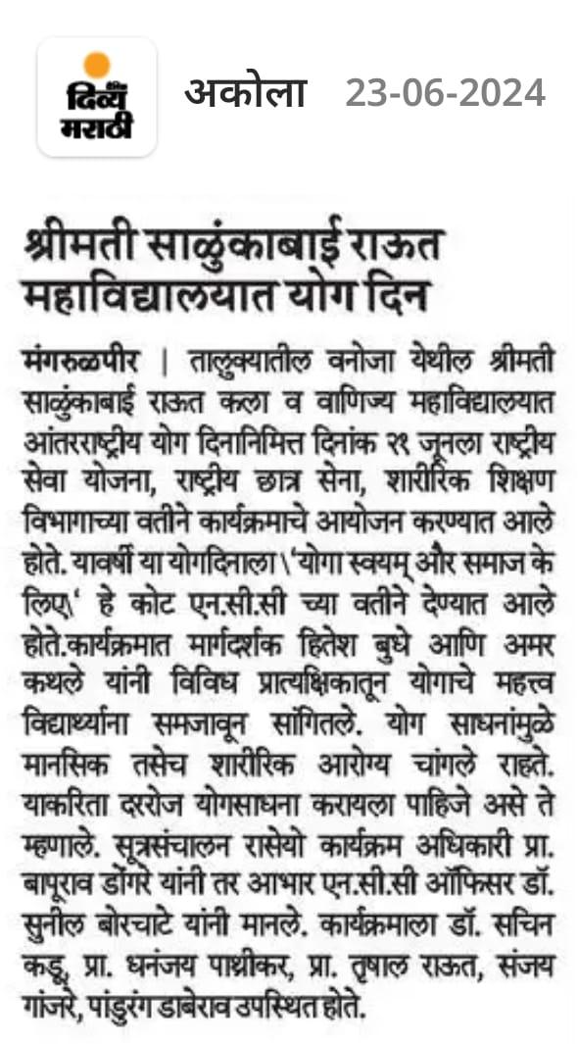
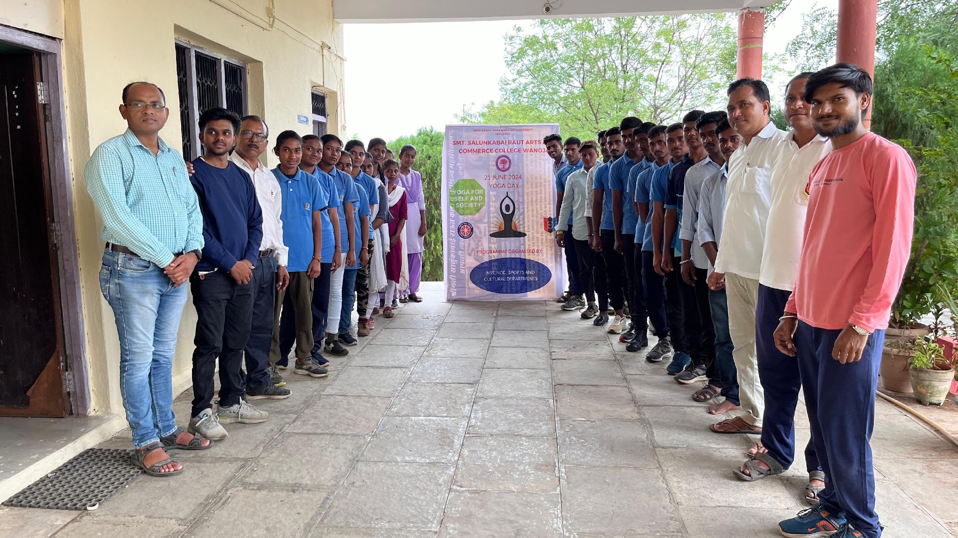

Yoga day celebrate by NCC Cadet in college unit

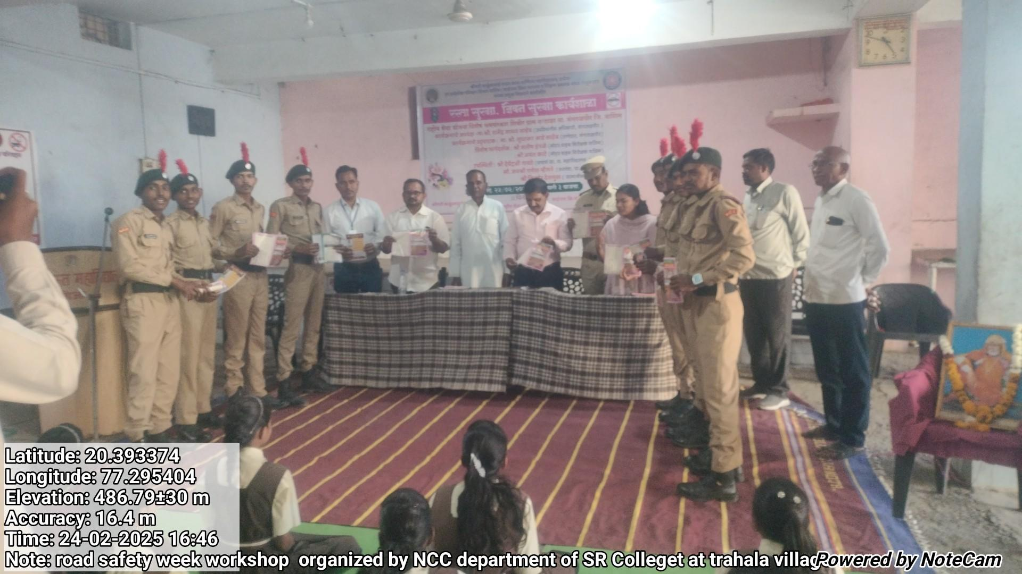
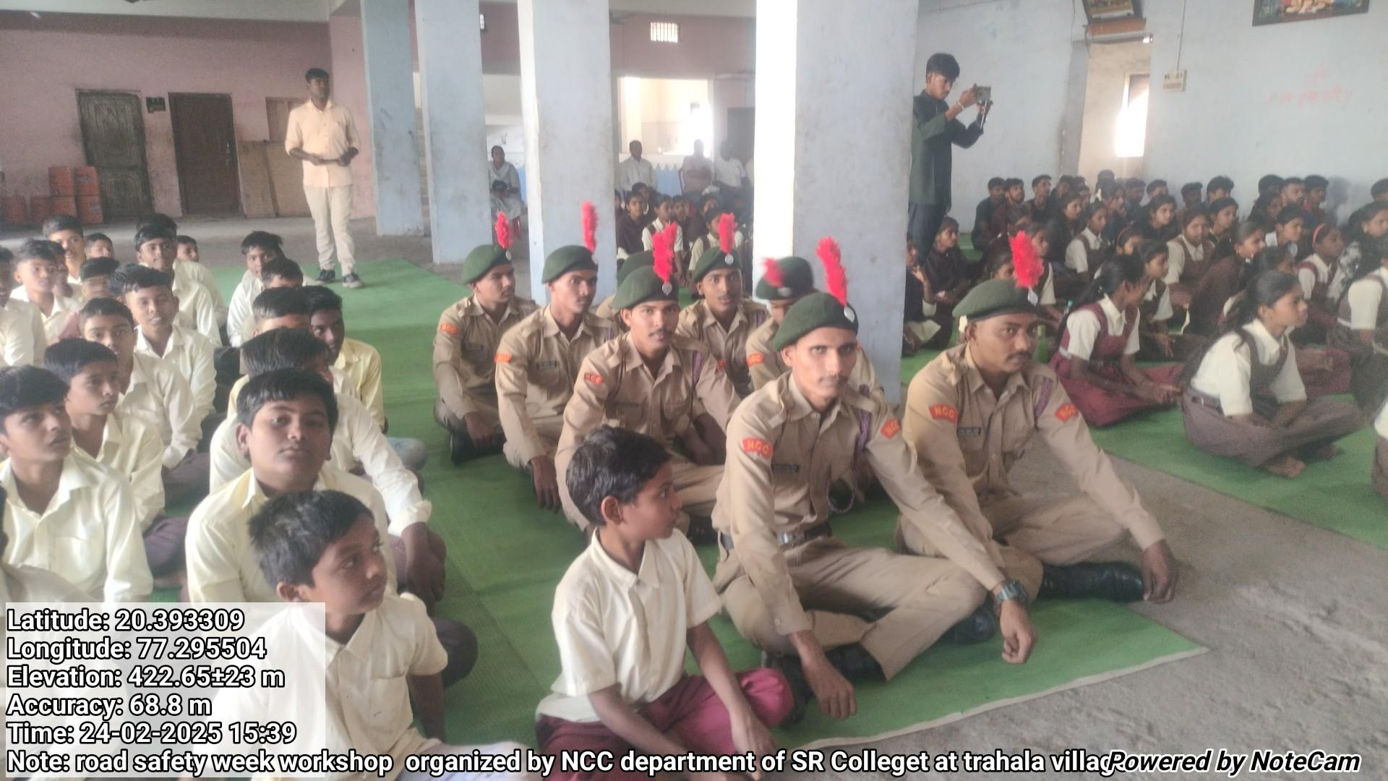
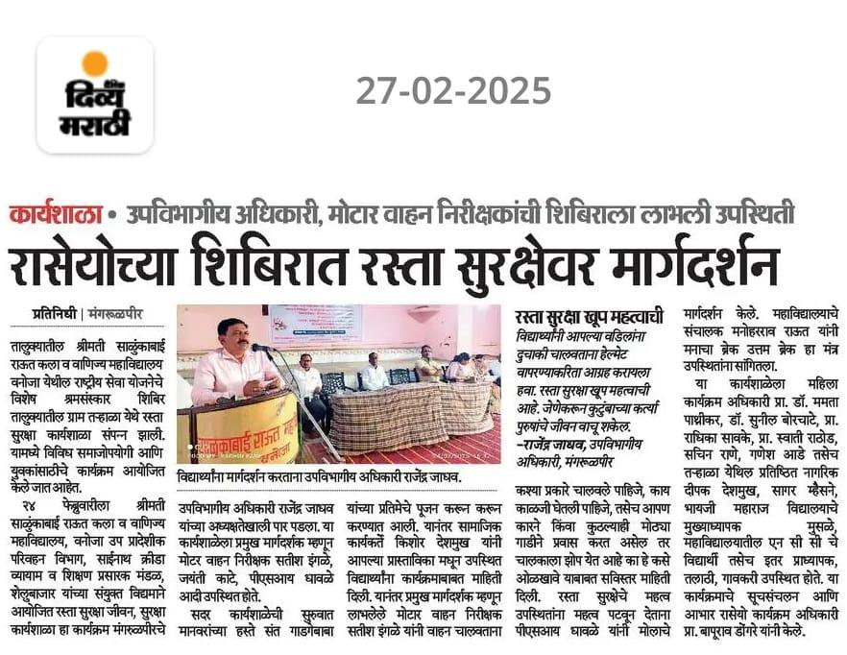
Road safety week workshop at nss camp Trahala village
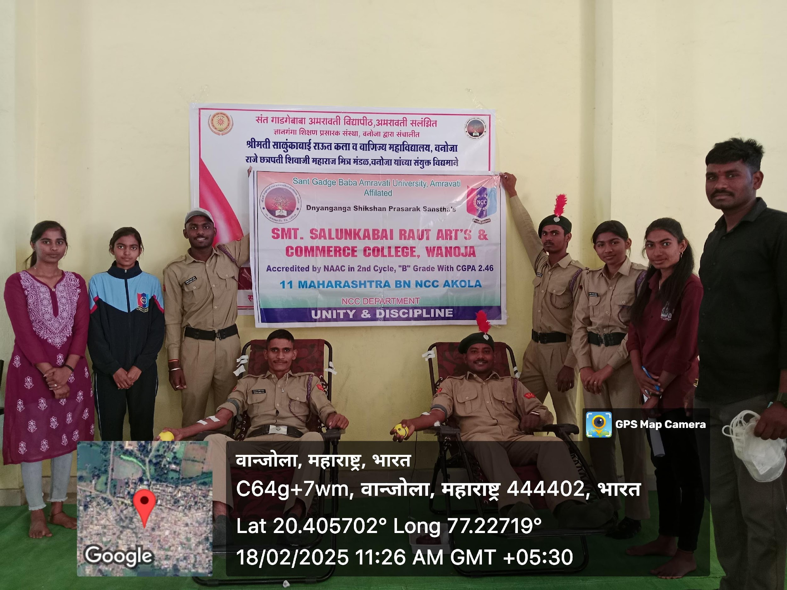

NCC Cadet donate a Blood in Blood donation camp
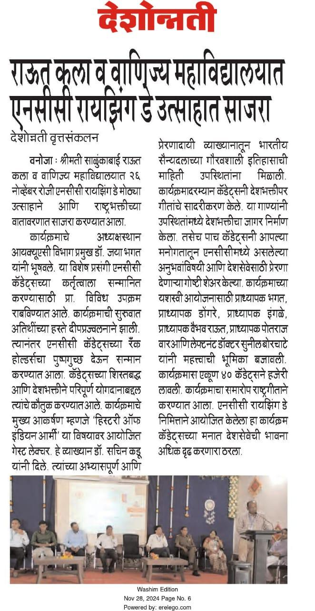

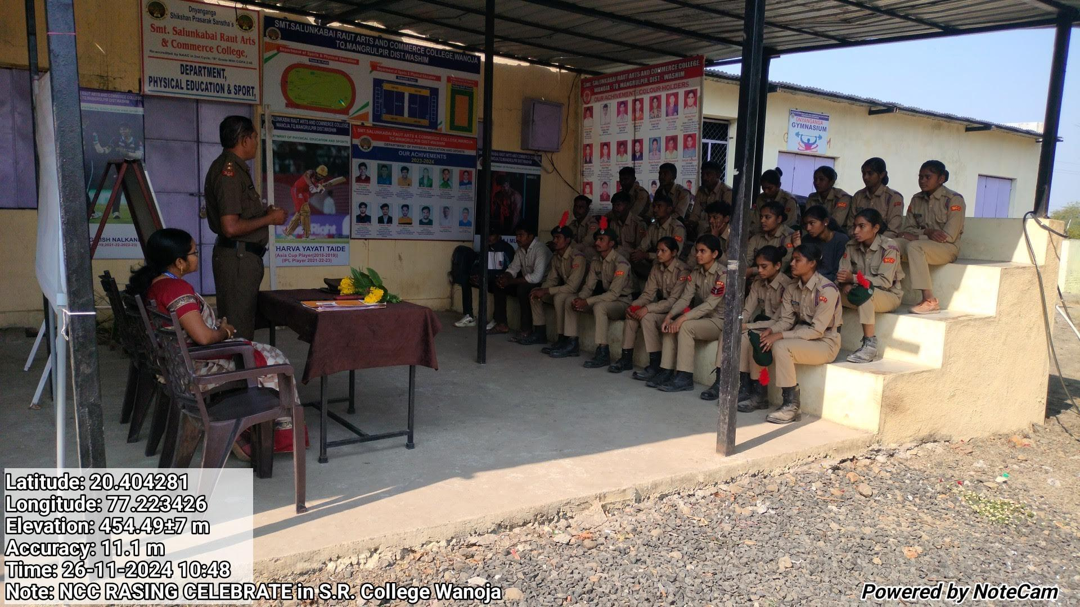

NCC Raising day celebrate in NCC unit

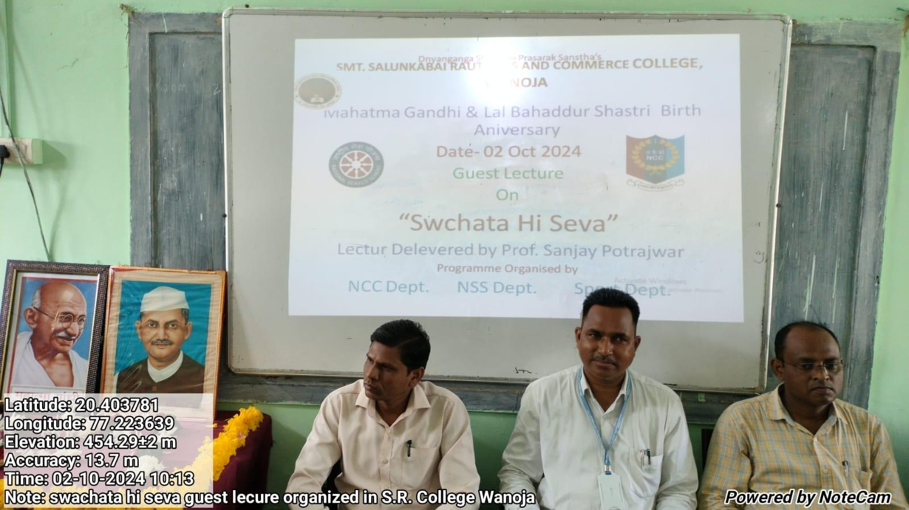

Sawchta hi seva on the topic NCC Dept. organized guest lecture

